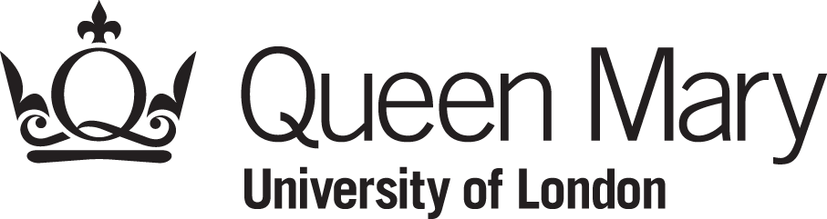
Bursaries, Grants and Scholarships Office
Nominated bank account form

Queen Mary University of London pays its students by BACS. Payments will be sent directly to your nominated bank or building society account.

Please make sure that the information you give us is clear and legible as it can be difficult to retrieve payments made to an incorrect account.
It is your responsibility to check the details are correct and to cancel or amend any payment instruction held by QMUL.
Signed

Name (please print)

Date

Part 2: Your bank account details
Bank name
e.g. Barclays, Lloyds, Natwest
Account name(s)
this would normally be your name

Account number

Sort code

Building society roll number
if applicable
Part 1: Your personal details
Student ID Number

Your title (tick one box only) |  | Mr |  | Mrs |  | Miss |  | Ms |  | Other

Last name

First name(s)

E-mail address

Term time address

Postcode

